**Name: Sanio Luke Sebastian**

**Roll No: 35**

**Batch: B**

**Date: 06-06-2022**

**NETWORKING & SYSTEM ADMINISTRATION LAB**

**Experiment No.: 14**

**Aim**

To study & know about the implementation of cmake tool.

**Procedure**

CMake is an open-source, cross-platform tool that uses compiler and platform independent configuration files to generate native build tool files specific to your compiler and platform. The CMake Tools extension integrates Visual Studio Code and CMake to make it easy to configure, build, and debug your C++ project.

1. **apt show cmake:** This command is used to know about the package, version available, descriptive information and much more about the mentioned tool/software.

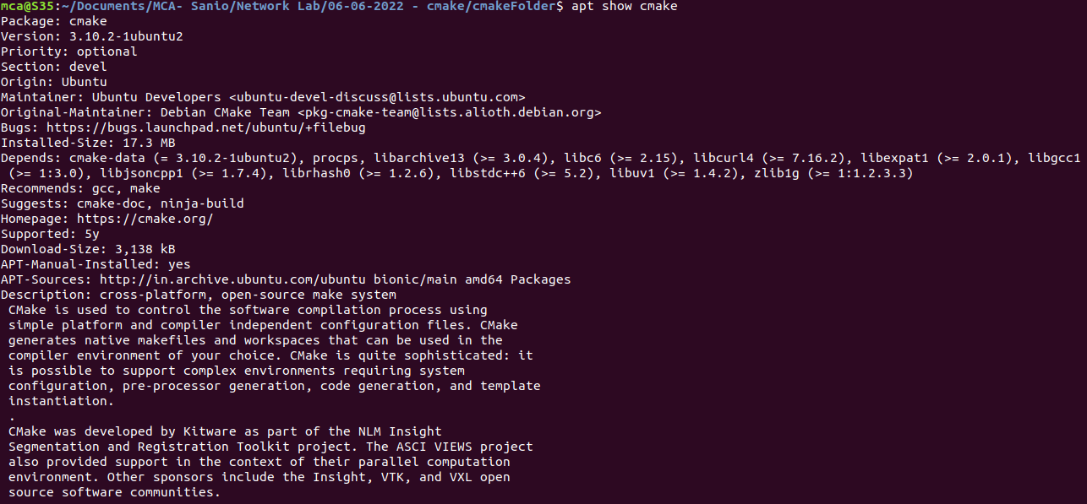

1. **sudo apt install cmake g++ make:** This command is helps to install cmake tool into the system. Along with the cmake, we have to install the **g++** and **make** tool with accompanies the cmake tool.

The g++ command is a GNU c++ compiler invocation command, which is used for pre-processing, compilation, assembly and linking of source code to generate an executable file. And the make command uses information from a description file, which you create, to build a file containing the completed program, which is then called a target file.

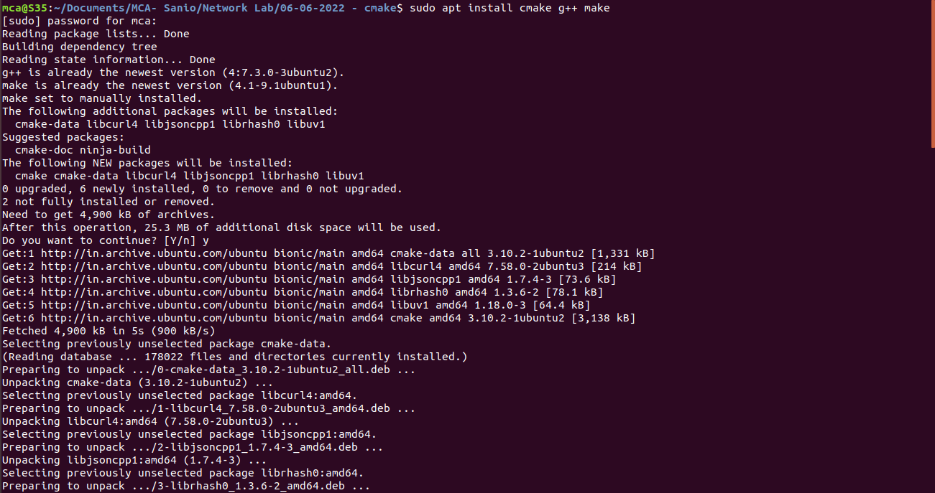

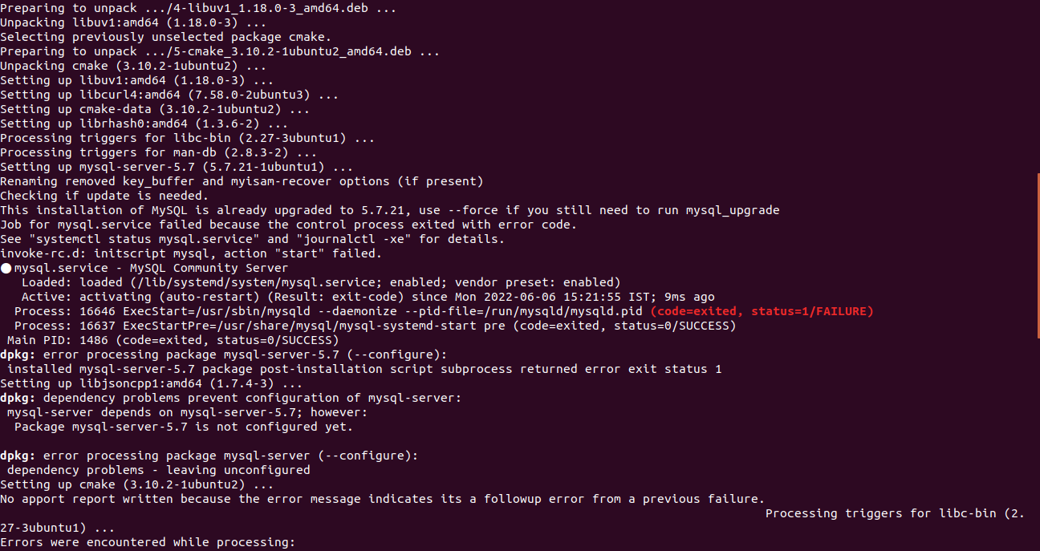

The main purpose of the cmake is that it helps to create a object byte code file of the .cpp/c++ program, which is compiler on any device and won’t require any specific compiler to run the file.

Now, after the install of the cmake, first we have to create a folder for the c++ program to run and build packages and build files, etc and in together form as a cpp project for the c++ program. Then within that folder, we have to create the cpp program file along with a cmakelist.txt file which contains the conditions to execute the cmake command and create an executable project for the .cpp file.

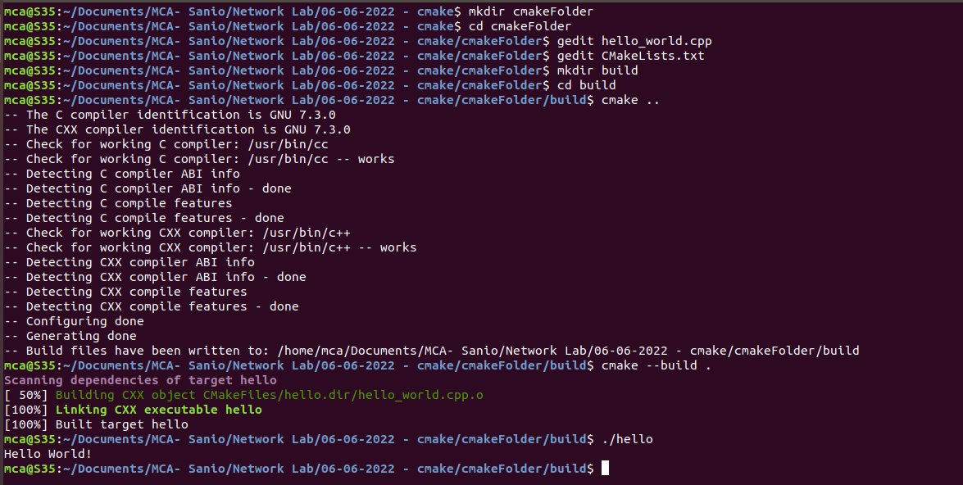

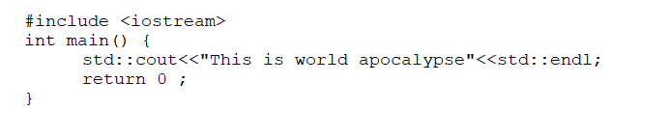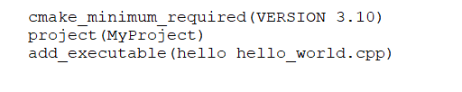

Now after successfully creating the files, we have to create a folder called “build” to contain all the build files created from the execution of the cmake. This will help the cpp file to execute without help of any compiler. And cd to that build folder to execute the cmake command.



After that, we have to execute the cmake command to create the project. The command should be executed within the build folder.



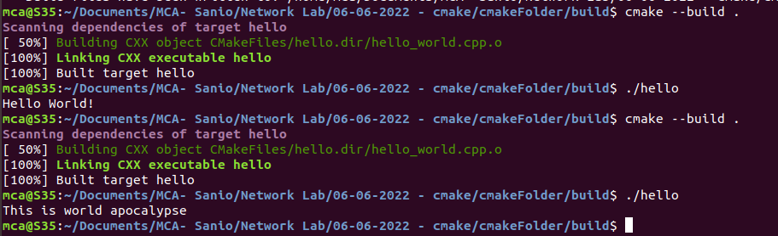

Then, finally to view the cpp file result, run the command below staying within the build folder:

**/build$ ./hello**

(NOTE: Here, the hello represent the name that was written the cmakelist txt file)**.**